Name: Nitin Ramadoss
Date: 04/14/19
19.03 Elevens Lab Worksheet
Directions: Make note of your responses to the following questions as you work through the activities and exercise in the lesson.
Activity 6 Questions

- List all possible plays for the board 5♠ 4♥ 2♦ 6♣ A♠ J♥ K♦ 5♣ 2♠
The 5♠ with the 6♣ make 11. The 5♣ with the 6♣ also make 11.
If the deck is empty and the board has three cards left, must they be J, Q, and K? Why or why not?

- If there are three face cards left, there must have been three previous plays of face cards. If the remaining cards are not JQK, then each face card rank wasn’t played the same number of times. This can’t happen.
- If there are two or one face cards left, we get a contradiction
If none of the three cards is a face card, there must have been a play of an odd number of nonface cards earlier in the game, as there are 40 nonface cards in all. This play would have been illegal.

- Does the game involve any strategy? That is, when more than one play is possible, does it matter which one is chosen? Briefly explain your answer.
When there is a choice between two or more different plays, it doesn’t matter in which order they are played. Therefore there is no strategy involved

Activity 7 Questions

- What items would be necessary if you were playing a game of Elevens at your desk (not on the computer)? List the private instance variables needed for the ElevensBoard class.
Deck of cards and cards. The ElevensBoard class would need the instance variables in the deck and card classes
- Write an algorithm that describes the actions necessary to play the Elevens game.
Shuffle the deck;
Deal 10 cards;
While there is a move,
If a pair exists that sums to 11,
Remove the pair;
Replace the two removed cards if possible;
Else if a triplet that contains J, Q, K exists,
Remove the triplet;
Replace the three removed cards if possible;
If there are no cards left on the board, you win, or else you lose.

- In the partially-implemented ElevensBoard.java file, does the class contain all the state and behavior necessary to play the game? Explain.
In the ElevensBoard class, as written, there are no methods that actually select the cards to be removed, only ones to check
already selected cards.
- ElevensBoard.java contains three helper methods. These helper methods are private
because they are only called from the ElevensBoard class.

  - Where is the dealMyCards method called in ElevensBoard?
in the ElevensBoard constructor and newGame method
  - Which public methods should call the containsPairSum11 and containsJQK
methods?
isLegal and anotherrPlayPossible

 | 0 | 1 | 2 | 3 | 4 | 5 | 6 | 7 | 8
cards | J♥ | 6♣ | null | 2♠ | null | null | A♠ | 4♥ | null
returned  list | J | 6 | null | 2 | null | null | A | 4 | null
  - Suppose that cards contains the elements shown below. Trace the execution of the cardIndexes method to determine what list will be returned. Complete the diagram below by filling in the elements of the returned list, and by showing how those values index cards. Note that the returned list may have less than nine elements.

  - Which one of the methods that you identified in question 4b above needs to call the cardIndexes method before calling the containsPairSum11 and containsJQK methods? Why?
The method anotherPlayIsPossible needs to call the cardIndexes method before calling the containsPairSum11 and containsJQK methods. It needs to do this in order to get the indexes of all the cards on the board so that it can check to see if the board contains another pair of cards that sum to 11 or a JQK

Activity 8 Questions
- Discuss the similarities and differences between the games Elevens, Thirteens, and Tens.
Single player games, played on board with cards, need specific face cards or sum

- The instance variables for cards and deck are declared in the Board class. But it is the ElevensBoard class that "knows" the board size, and the ranks, suits, and point values of the cards in the deck. How do the Board instance variables get initialized with the ElevensBoard values? What is the exact mechanism?
super ( BOARD_SIZE, RANKS, SUITS, POINT_VALUES );
- List the abstract methods in Board.java. These methods are implemented in ElevensBoard. Do they cover all the differences between Elevens, Thirteens, and Tens as discussed in question 1? Why or why not?
No, abstract methods were implemented differently and require different private methods
Activity 9 Exercise Results
- After running the ElevensGUIRunner.java class, describe what you see and experience. Take a picture of the screen and paste it below, if you like, along with the description.
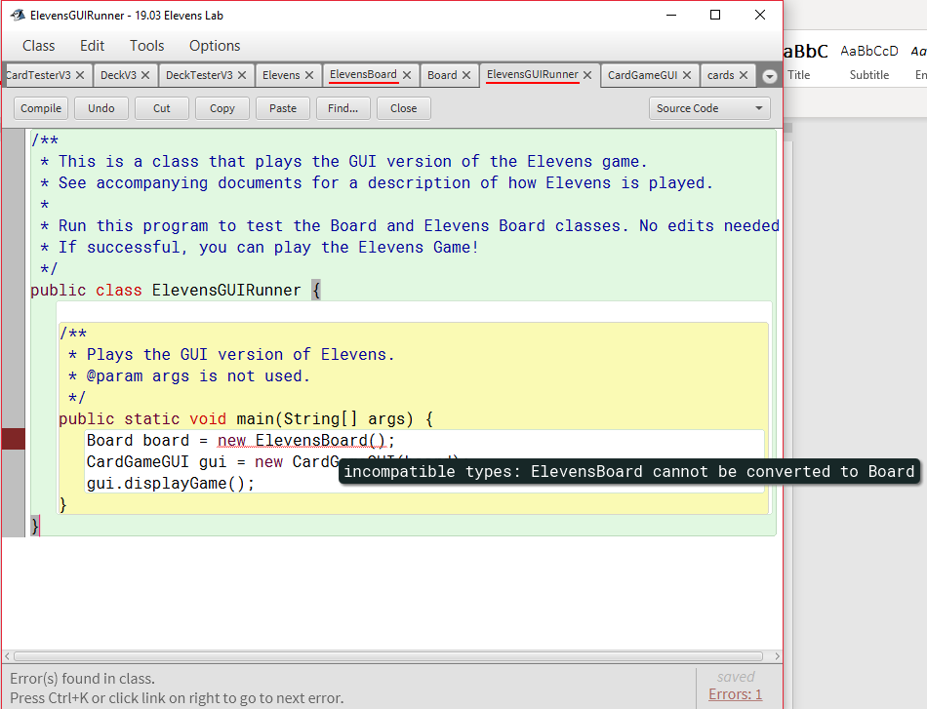
Activity 9 Questions
- The size of the board is one of the differences between Elevens and Thirteens. Why is size not an abstract method?
They are private boolean
- Why are there no abstract methods dealing with the selection of the cards to be removed or replaced in the array cards?
They are private static methods
- Another way to create "IS-A" relationships is by implementing interfaces. Suppose that instead of creating an abstract Board class, we created the following Board interface, and had ElevensBoard implement it. Would this new scheme allow the Elevens GUI to call isLegal and anotherPlayIsPossible polymorphically? Would this alternate design work as well as the abstract Board class design? Why or why not?
No, this new scheme not allow the Elevens GUI to call isLegal and anotherPlayIsPossible polymorphically, this alternate design does not work as well as the abstract Board class design because it do not state detail process.

public interface Board
{
boolean isLegal(List<Integer> selectedCards);

boolean anotherPlayIsPossible();
}

